Included files in PEDRA 9.0.1
There are eleven data files included in the PEDRA 9.0.1 Download. The nine data files on the top of the list concern high impedance data. The four data files lower on the list concern low impedance battery data. These files are an example of the current capability of PEDRA, which offered as a ‘work-in-progress under a MIT license is free for the user do share, modify, sell etc. any modifications of the program. The intent is to broaden our thoughts on the EIS technique and to promote its use and acceptance.
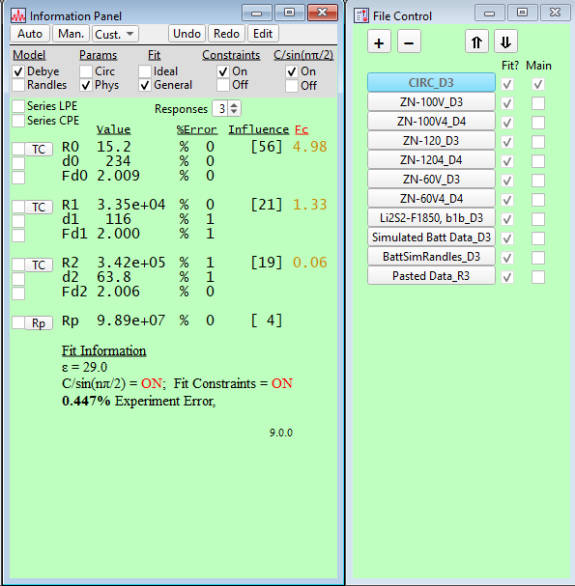
CIRC_D3
This is a circuit box based on a 100V anodized (polycrystalline) oxide film on a two phase Zr2.5Nb alloy. Because the box contains resistors and capacitors, the data file approaches ideal response; n = 1 (population distribution) or Fd = 2 (fractal). Results shown here are in physical form so that the fractional/fractal parameter is used rather than the electrical power law term.

The circuit box is in Debye (parallel dielectric response) and fitted to a Debye model and reported in physical dielectric parameters. The alternate form and/or circuit parameters can be seen by checking the appropriate box and clicking on manual (Man.) fit.
As expected, parameter error is minimal, Experiment error very low 0.45% and each response having significant influence on the overall spectra. Finally, the position of each Cut-Off frequency, Fc, (point at which the capacitance starts to block current through the AC pathway) is in red to the right of the influence.
The Main Graph shows this information as stacked graph with residuals under the plot. By default, the left axis shows the impedance ratio Zimag/Zreal. This is like the phase angle (ArcTan(Zimag/Zreal) except it is related to the dominance of blocking capacitive effect or limiting resistance effect of the current path as a function of log frequency. The default right axis, used to guide the iterative data fitting is a Gaussian line graph of the fit parameters. The height is either capacitance or dielectric (oxide) thickness, position Log (Fc) and the width proportional to the power law term. Because the circuit box is near ideal the peaks are very narrow. The advantage of this presentation is that it show the exact locations where each response (current path) is active in the spectra and it can be used to immediately overlay responses for different data sets.
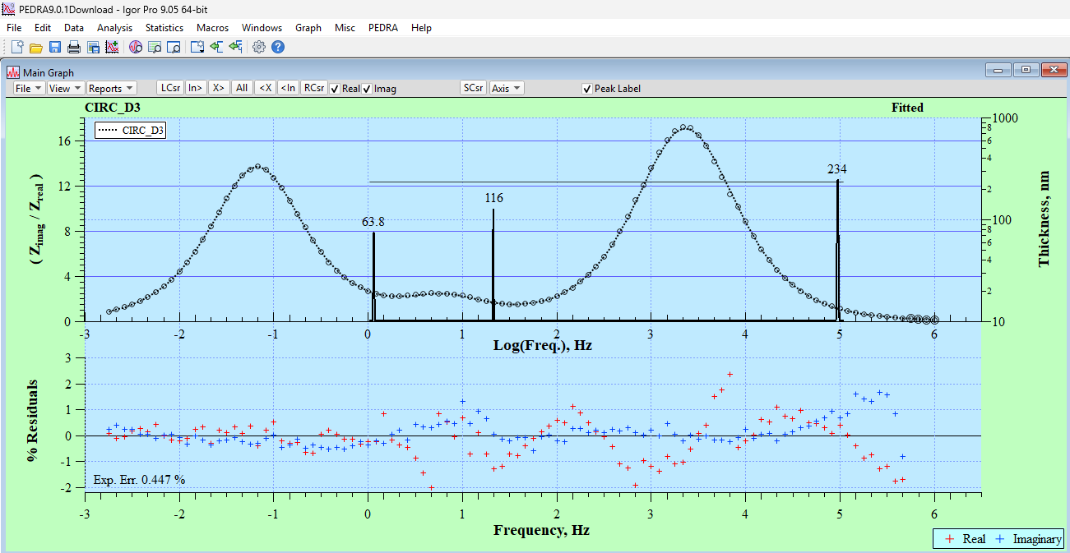

The 2nd data file, ZN100V_D3, is the anodized oxide film on which the Circuit Box is based.
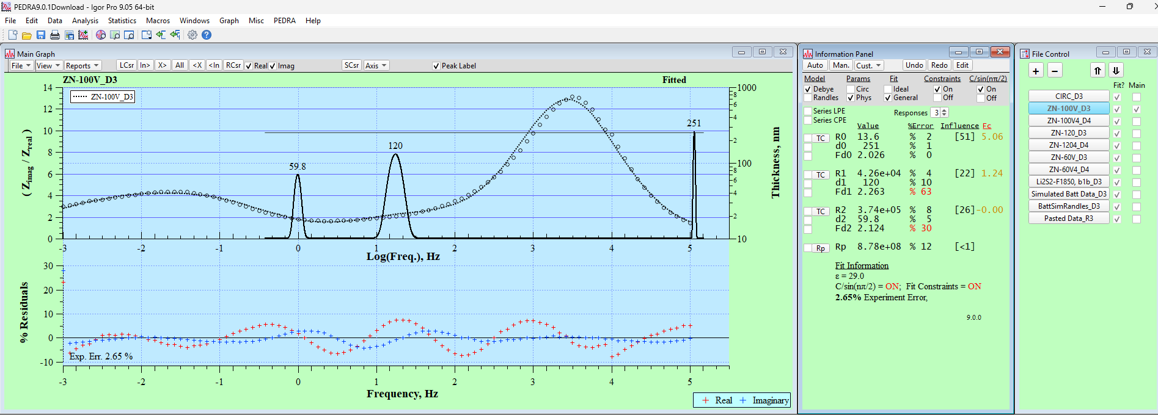
Compared to the near ideal circuit box, the anodic oxide exhibits broader peaks with similar resistances. What maybe less obvious is the much higher Experiment Error, 2.65% and although each responses influence is similar to the circuit box, the parameter error is larger. In addition, close inspection of the Zimag/Zreal Ratio plot reveals a cyclic above below behavior of the fit line through the data points. To the more experience eye this implies that there maybe more information in the data than the presumed three responses.
The 3rd data set, ZN100V4_D4, is the same data fit to four dielectric responses. The Main Graph shows that the second response divides into two, reducing experiment error to 0.96% and lowering parameter error. However, as the indicated by the red % Held text, two parameters were held during the final fit. This is because the two center responses are close to one another causing some of the parameters to influence the other (correlation between parameters). Also, Rp now has lower influence in the overall fit and thus its value is less well known.
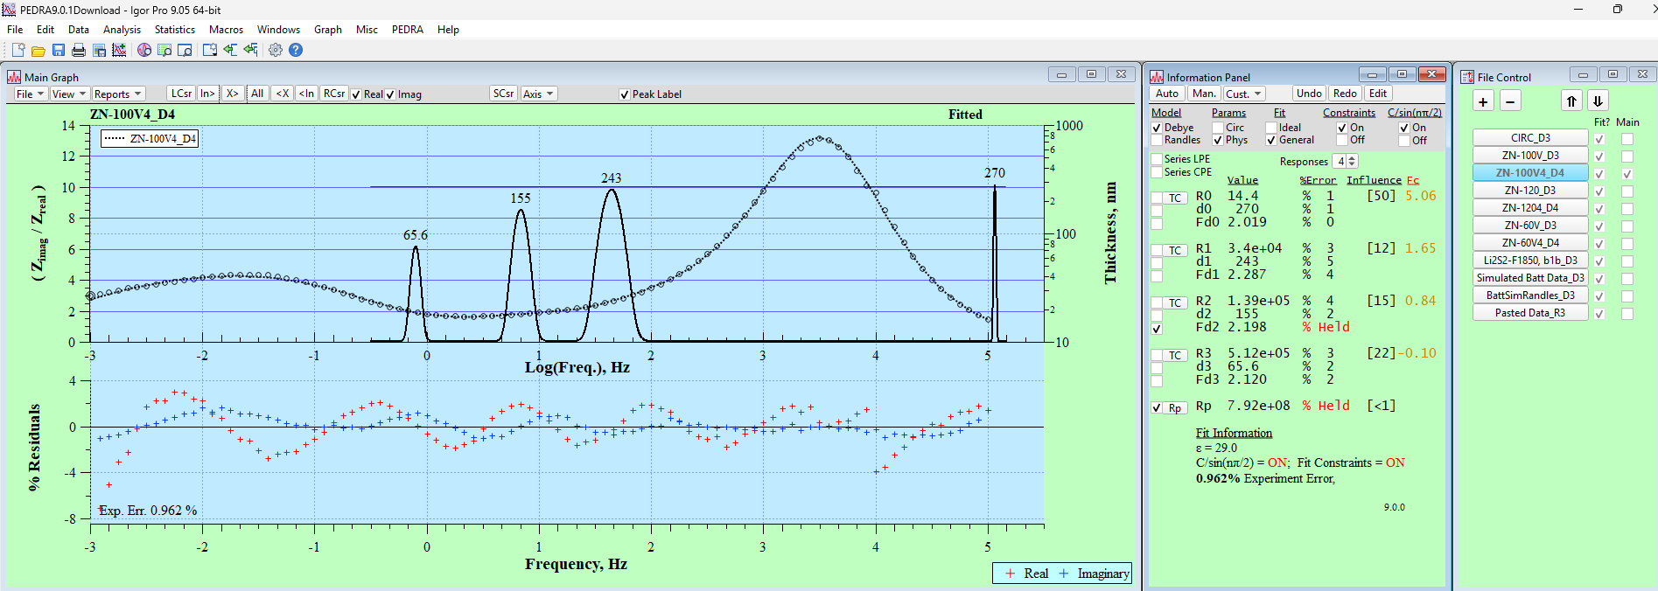
The next four data files, ZN-120V_D3, ZN-120V4_D4, ZN-60V_D3 and ZN-60V4_D4 are similar treatments for the 120V and 60V anodizations. These are included to demonstrate the ability to overlay both the Zimag/Zreal ratio data fits and some of the reporting options of PEDRA.
First shown is the data overlay. Selecting the ZN-100V_D3 file, clicking the Man. Calculate button to show the fit and selecting the check boxes for ZN-120V_D3 and ZN-60V_D3 under the ‘Main’ column of the File Control panel, the fits can be overlayed with one another. This no only compares the fits but ensure that they are consistent with changes in the oxide film.
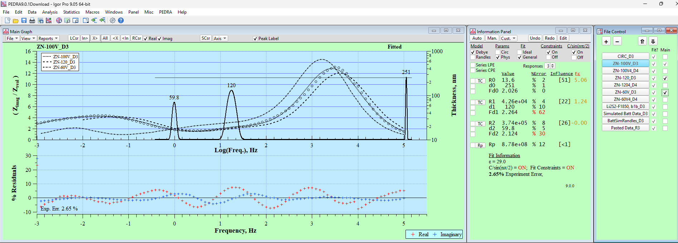
Next, the reporting capability will be shown.
By again selecting the ZN100V_D3 file and refreshing the fit (clicking on Man. In the Information panel), for any file that indicates it has been fit, the first column of check boxes in the File Control panel, results can be overlayed with one another.
There are five report options to choose from; overlay plots can be used for any of them. The two SpecView options are most useful. Spec vs LogFreq, creates a Bode type plot with Log (Fc) as the x-axis. Although this is useful, if it is the physical parameters that want to be compared, the Bode plot by selecting Spec vs Log R, all the physical (or electrical) parameters can be compared on one graph. The physical significance concerning dielectric response is that the resistance, inversely proportional to the conductivity, the dielectric thickness and population distribution of small contributions to an overall response can be appreciated in one graph. The advantage of this clarity can not be over estimated when trying to present multiparameter data to an unfamiliar audience, be it peers or share holders who need to be convinced of the worth of the technique.
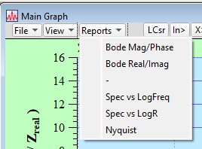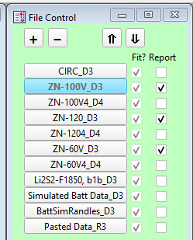
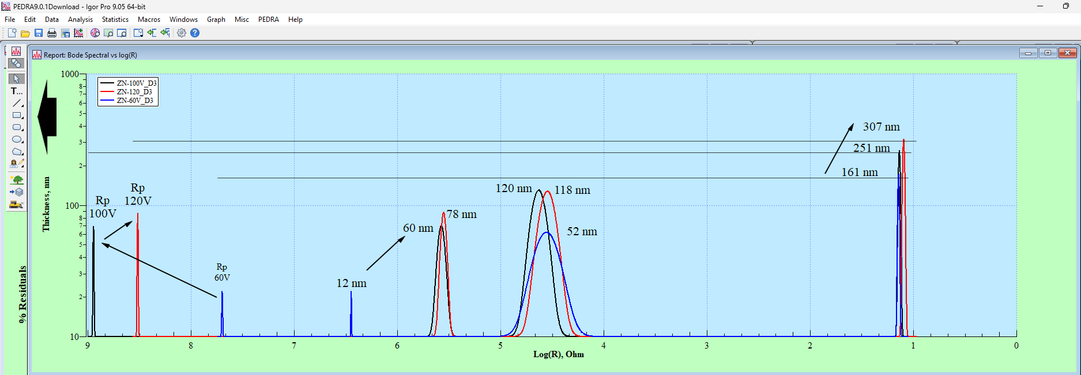
The above Result plot is comparing the 60V, 100V and 120V results. In addition to the advantage of the Gaussian (SpecView) plot is the fact that the plots annotations, changes to the axis, IGOR tools bar (shown on the left) can be used to quickly highlight important information that the plot contains. In the case of anodic oxide films the growth of the barrier oxide (right peak) can be compared to internal porosity (middle two peaks) and changes in the polarization resistance (for visual purposes the height of the Rp peak is the same as the same data file peak adjacent to the right). Comparison of other Bode presentations are left to the user.
Shown below is the optional Nyquist plot of the results. In the case of high impedance films the axis need to be changed to a log scale, which is easily done be selecting the axis and changing axis attributes.
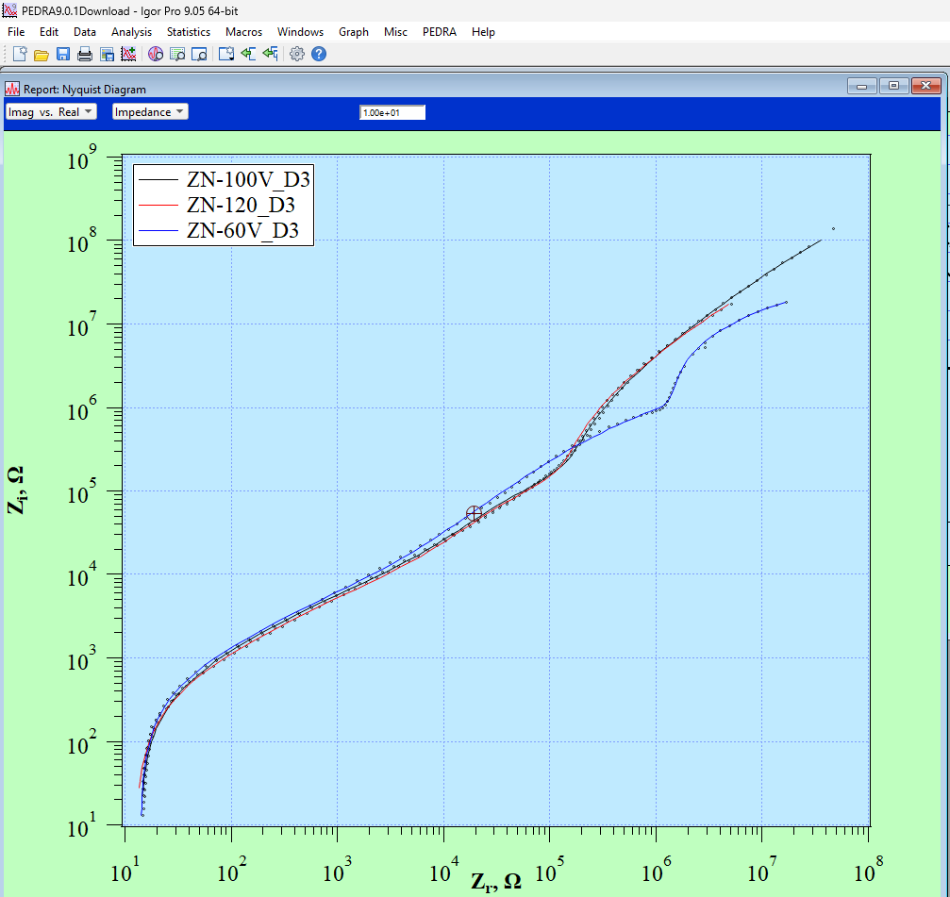
The final four data files, pertain to low impedance battery applications, and in addition details about changing fit constraints to aid in iterative fitting, the Gaussian baseline to display physical and electrical peak heights and relative peak width.
The Li2S2 is an actual data file an Lithium battery. The data is not very well behaved, however was still able to achieve a fit to three responses. The pervious high impedance data files were fit using contraints tuned to the high impedance range. Constraints for the low impedance battery application are quite different. In addition, where as the high impedance barrier films lend themselves toward physical dielectric attributes, low impedance battery data lends itself to circuit dielectric attributes. For high impedance resistance can range many orders of magnitude and the thickness just a few. Conversely for low impedance battery applications it is the capacitance that has a large dynamic range and a narrow resistance range. Because of this the y-axis requires changes to display the data well. Both contraints and axis adjustments using the preference menu are described below.
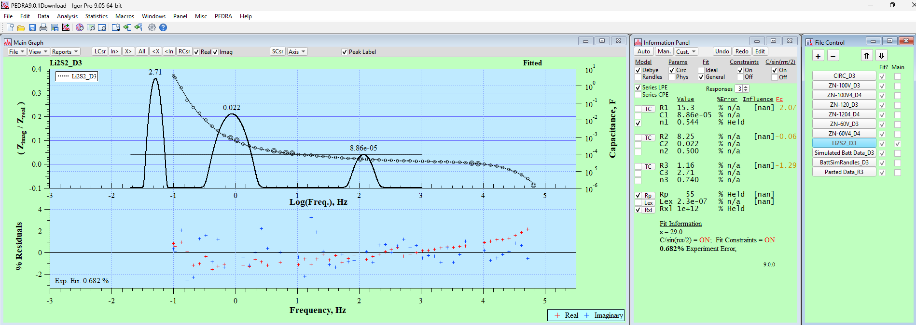
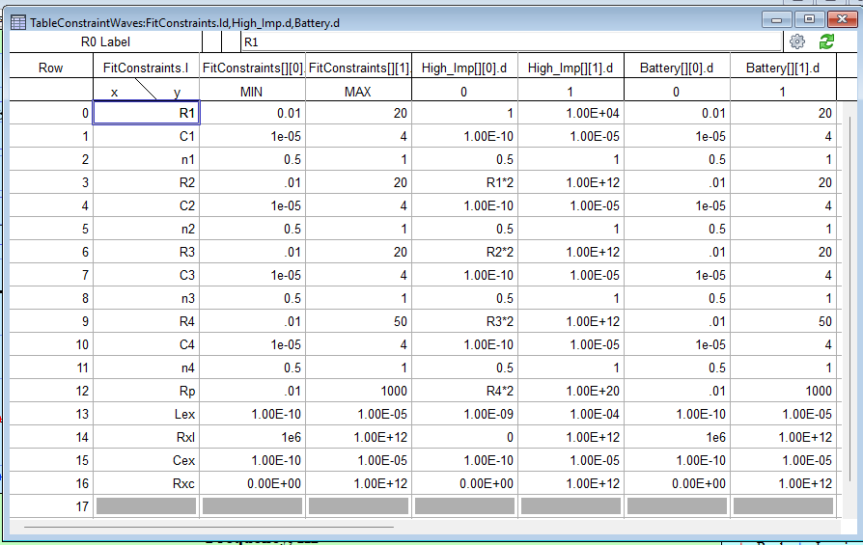
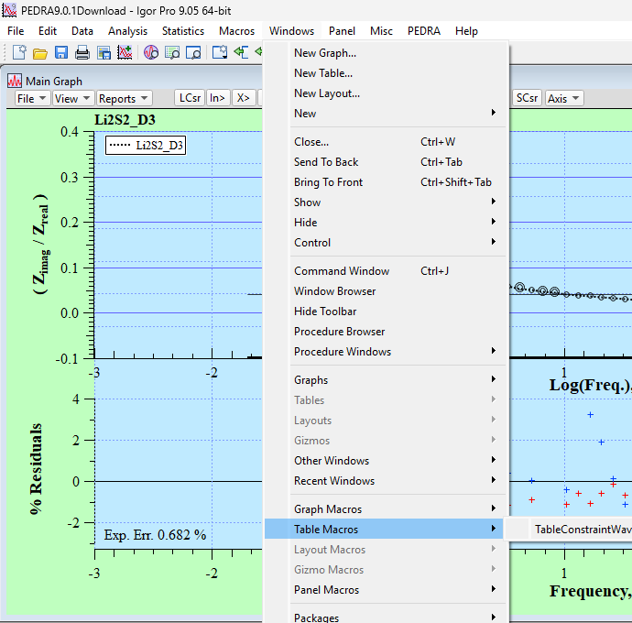
Constraints need to be customized based on the value range of the parameters. Sets of constraints can be stored in PEDRA and switched as required. To open the constraints Macro Table use the IGOR window pulldown menu and select Table Macros:TableConstraints. The parameter names and current constraints are in the left columns. Other constraint sets are in the pairs of columns to the right. IGOR allows variable equations, such as R2 = R1*2 in the high impedance set. Equations however are not used for reistances in the Battery constraints because of the narrow range of resistance. The use of constraints help the fit to converge, while minimizing fit crashes. However if the constraints are too narrow they will be a cause of fit crashes and too wide they offer not advantages. Additional constraint files can be added by duplicating the FitConstriant waves and naming the created waves accordingly. The waves can then be added to the TableConstriants and the Macro saved, overriding the existing Macro.

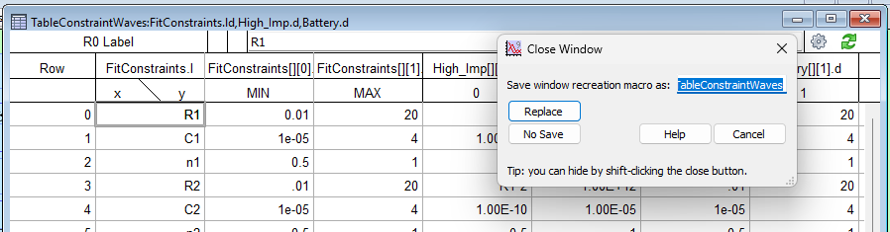
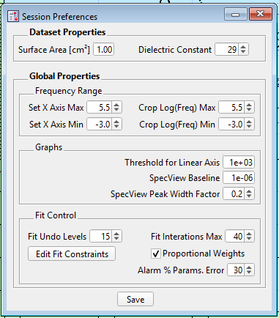
Adjusting the SpecView y-axis is done in the Preference window at the bottom of the PEDRA File pulldown menu. There are three controls: Threshold for Linear Axis, SpecView Baseline and SpecView Peak width factor. The Threshold set the point where the axis changes from a log scale to a linear scale. The default is 1000 ohms. This is useful for low impedance data that includes inductance because negative Zimag values (i.e. convention for inductance). This problem doesn’t present itself for Nyquist plots, but is necessary for Bode presentation, which has lots of advantages over the Nyquist plot. The SpecView Baseline adjust the baseline of the Gaussian plot to control the range of the y-axis which starts at the baseline and end at a ‘nice’ value above the highest value in the results. For Zr2.5Nb anodic oxide films the ceiling is about 1,000 ohms and a baseline of 1 or 10 works well. For battery data, reported using circuit parameters the capacitance can range from 1e-6 to 20 Farads, requiring a base line of 1e-6 and seven orders of magnitude or much narrower 1e-3 to 20 Farads. The baseline can be changed in the preference menu and the immediate result reflected in the graph. The Peak Width Factor allows the user to adjust the relative width of the peaks so that they persent well on the graph. Near ideal response n close to 1 would use a wide Width factor, whereas for data having lower values of n a lower Width factor is useful. Another situation is in the case of separating peaks that are near each other as shown in the two graphs below.
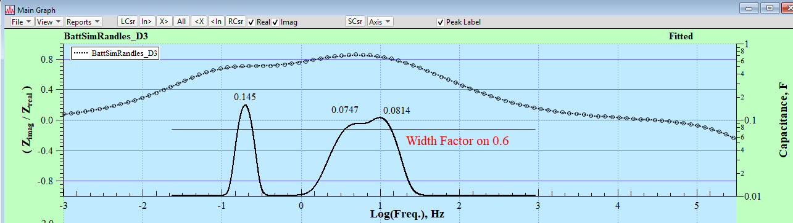
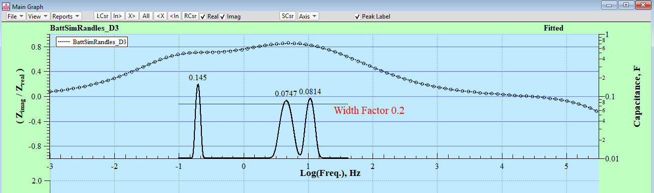
Fitting Batter data can be a bit more challenging than fitting high impedance data. One reason is including inductance in the fit and the other is the narrow resistance range. The greatest challenge is in defining the constraint values. The constraint values can be determined from the initial values determination. If the TC button is check in front of a response and the cursor moved along the position of the data, clicking the box a second time enters the estimate into the response in the Information panel. If this is repeated for other locations the range of the parameters is determined. In addition, as mentioned, if the resistance range is narrow than descrete values rather than parameter equation work better. Currently there isn’t a method to estimate the inductance, however it is typically between 1e-5 to 1e-10. It is also helpful to use the omit data point control to omit the high frequency data points that include inductance (i.e. Zimag/Zreal < 0), perform the fit to determine the number and position of the dielectric responses present, then select the Series LPE. Selecting the Series LPE brings up the edit parameter controls allowing the user to optionally adjust values. Note: after changing a value hit ‘return’ before selecting ‘Click to Return Values’. This dialouge is also useful to change and hold parameters without having to perform the initial value routine again.
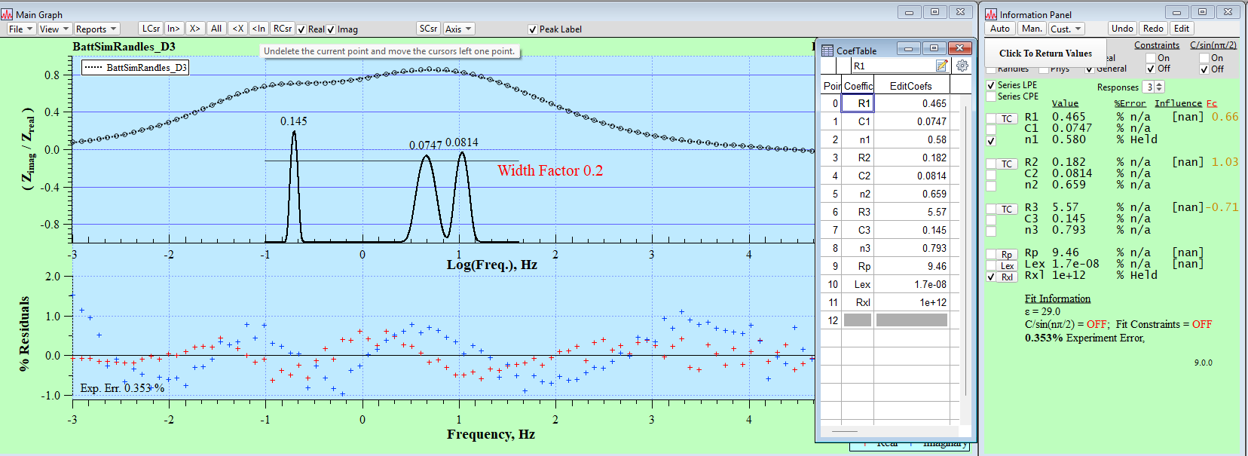
The last two data files use the same data, however one is fit using the Debye form (independent parallel responses) and the other Randles form (dependent cascading responses). As expected the values of capacitance do not change significantly, however there is observable changes in the mid-resistance peaks.
Log(R)
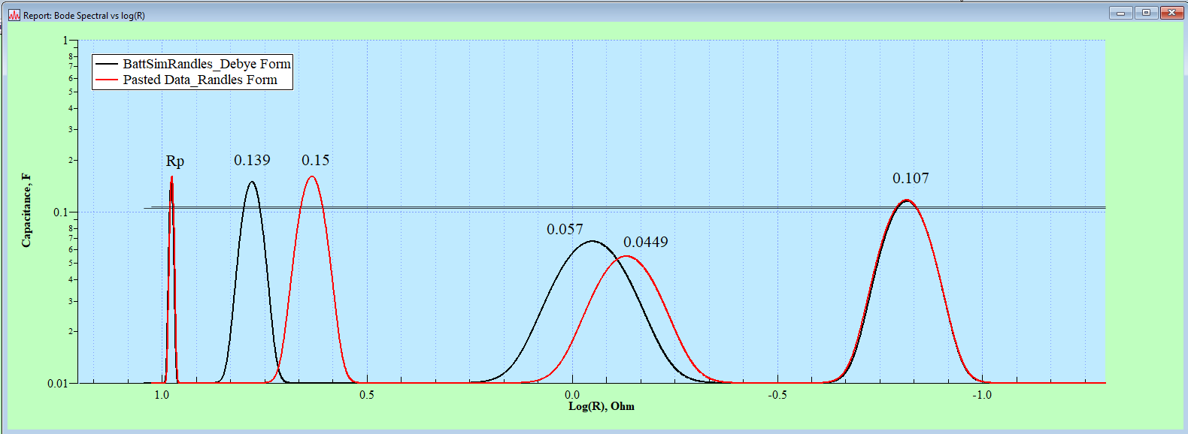
Log(Freq)
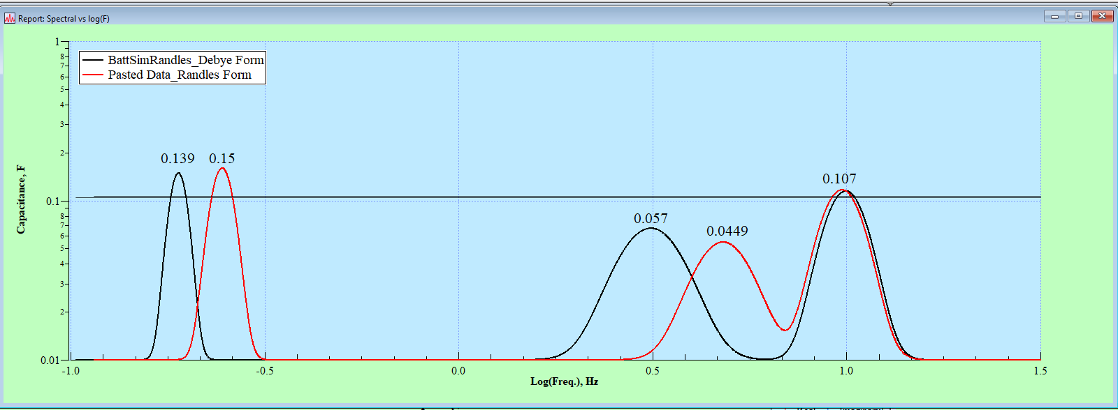
This ends the tutorial on PEDRA 9.0.1. The authors wishes you well in all your research efforts. If you have any questions or inquiries use the response form on the website: eispedra.com.

