Development of a Screening Test for CANDU Pressure Tubes
Abstract
This report originates from an internal memo drafted in 2004. Two unirradiated CANDU pressure tubes (PT) front-end offcut sections (i.e. PT section cutoff prior to power reactor insertion) were used to develop a predictive method of in-service behavior. The L1S16 PT demonstrated significantly lower Deuterium (D) uptake than L1F10 after exposure to more than 10 years of in-reactor service. Oxide films formed on front-end offcuts (i.e. the end at the higher temperature downstream position in-reactor) after to a single 400 °C air, 7-day exposure were evaluated. The thickness of the surface oxide was determined by employing Fast Fourier Transform Infrared (FTIR) Spectroscopy [1]. The inner barrier oxide was determined using Electrochemical Impedance Spectroscopy (EIS) [2,3]. Cross-sections of the oxide were prepared using Focussed Ion Beam sectioning (FIBS) and examined using Transmission Electron Microscopy (TEM) [4,5]. The study concludes that in-service behavior correlates with the accelerated 400C air exposure for these PTs [6,7].

Experimental Procedure
Specimens about 3 cm square were cut from front-end pressure tube offcuts, L1S16 and L1F10 [5,6}. The surface was prepared by wet sanding with 320 grit SiC paper [8]. This preparation has previously been demonstrated to yield a uniform surface finish with a surface roughness about that of production pressure tubes [7]. Samples were oxidized in air for 7 days at 400 °C. FTIR spectra were acquired using a BIO-RAD FTS-40 spectrometer equipped with a DTGS detector. EIS spectra were collected over a frequency range of 0.008 Hz to 100 kHz using a 100 mv AC perturbation. EIS data was fit using custom application: Parallel Electrical Dielectric Response Analysis, PEDRA 9.0 2025. Cross-section oxide samples for TEM were prepared after performing FTIR and EIS measurements. FIBS TEM cross-sections were prepared using Micrion 2500 Focussed Ion Beam System [9] and examined with a 300 keV Philips CM 30 Analytical Electron Microscope equipped with an Oxford Instruments X-ray detector with an ultra-thin window.
Results and Discussion
Figure 1 compares the two specimen is the classical Bode Plot in electrical terms. There is a striking difference in both impedance magnitude (Log|Z|) and phase angle (ArcTan(Zimag/Zreal). Log|Z| is similar above and diverges below Log(Freq) of 2. Similarly, the phase angle is similar above and diverges below Log(Freq) 3.5. However, it is unclear how these electrical terms are related to physical changes in the barrier oxide itself.
Figure 2 shows the fit to the data on a Bode Plot using the simple ratio of Zimag/Zreal (rather than phase angle) and a Gaussian line plot of the physical parameters calculated from the electrical parameters (rather than Log|Z|). The ratio plot is used to estimate initial fit parameters, follow the iterative fit process and show the final fit to the data. The Gaussian line graph compares cut-off frequencies (position), the oxide thickness (height) and population distribution (width) of individual identified responses. In addition, the residuals of the fit, shown on the lower stacked plot axis, are used to judge data quality (linearity, stability and causality), omit data ‘outliers’ (circled data points in the Ratio plot) and calculate the error in the fit (Exp Err). Cyclic random residual and an Exp Err is below 3% demonstrates an acceptable fit. Further discussion of the fit process and data validation is beyond the scope of this report.
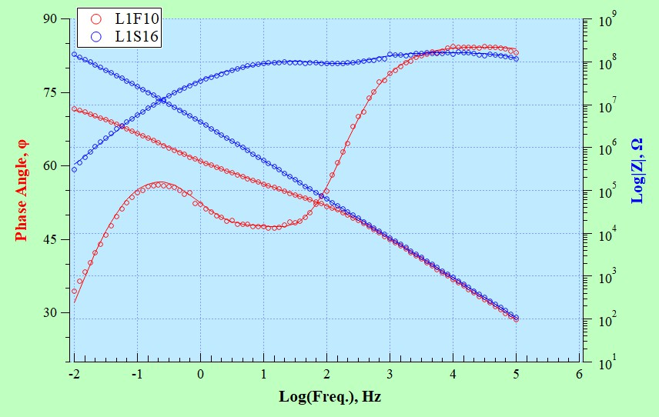
Figure 1: Classical Bode Plot of the fit to the data.
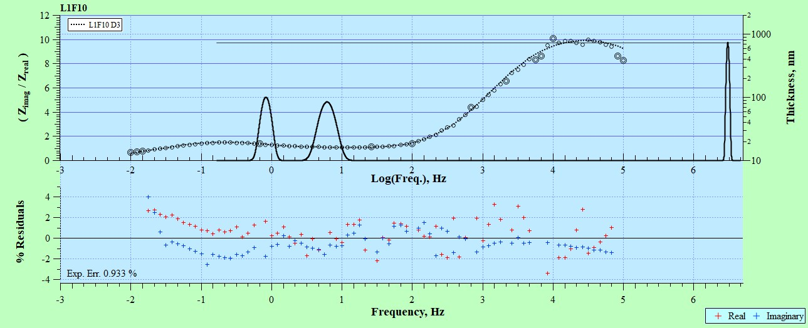
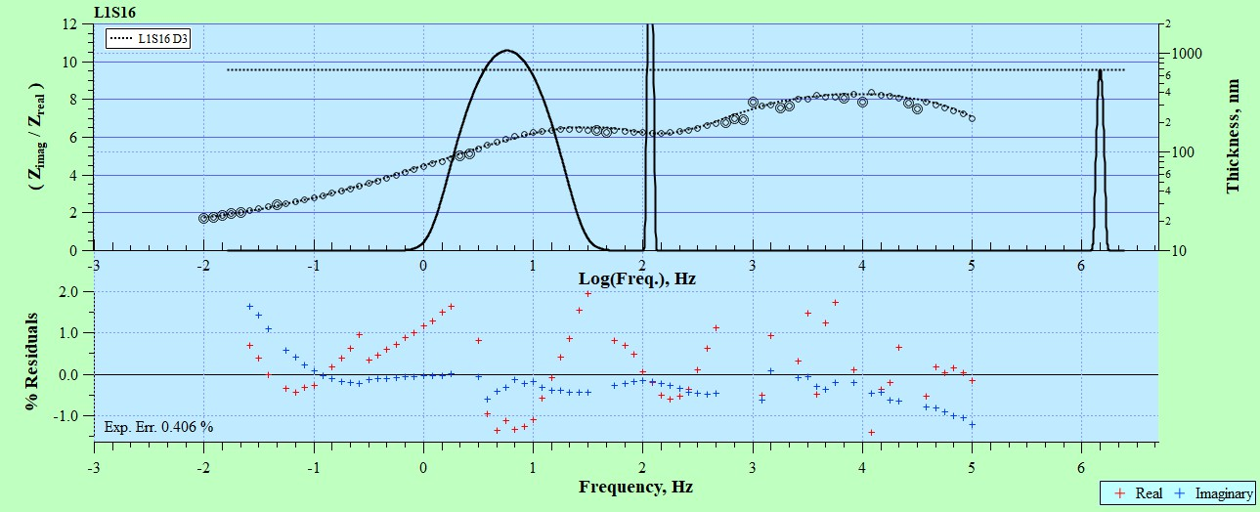
Figure 2: Fit to the Impedance Data using PEDRA 9.0, L1F10 upper and L1S16 lower.
Figure 4 shows the physical representation of the results as an overlay plot. Three characteristics (impedance) responses are present, along with the polarization resistance, Rp, representing the limiting direct current, DC, resistance of the barrier oxide (i.e. the height of Rp, arbitrarily set and has no physical significance). The peaks at low Log(R) are the barrier oxide thickness (not necessarily the total surface oxide thickness), which is about 700 nm for both specimens. The two central peaks show penetration of electrolyte into the barrier layer. For L1S16 the central peaks have thickness above the barrier oxide thickness, which indicates little internal oxide porosity (i.e. the effective area is less that the ascribed area of the specimen). In contrast, for L1F10 the electrolyte penetrates to about 100 nm of the metal-oxide surface, which indicates considerable internal porosity.
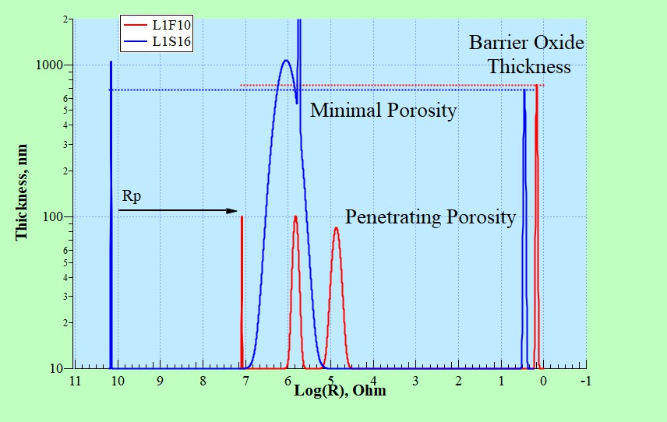
Figure 4: Physical Representation of the EIS results.
Table 1 reports the the values and error in measurement for both circuit parameters (R, C, and n) and physical attributes (R, d, and Fd). Effective capacitance is in units of Farads (i.e. accounting for frequency dependence Ceff = C/(sin(npi/2)). Effective thickness, d, is in units of nm. The n3 and Df3 parameters were determined by holding other response parameters and ‘Held’ for the final fit due to its low influence (i.e. high uncertainty) on the overall response.
Table 1: Fit parameters with their associated error in measurement
Figure 5 summarizes the results in a composite representation. The TEM cross sections are on either side of the center, L1S16 on the left and L1F10 on the right. There is considerable internal porosity in L1F10, while very little porosity in L1S16. In the center is the physical representation plot (shown in Figure 4) as well as a schematic representation of the surface oxide and the Expandable Equivalent Circuit Model (EECM) in Debye form used to fit the impedance data. A detailed discussion of the EECM implemented in PEDRA 9.0, while thoroughly established, is outside the scope of this report.
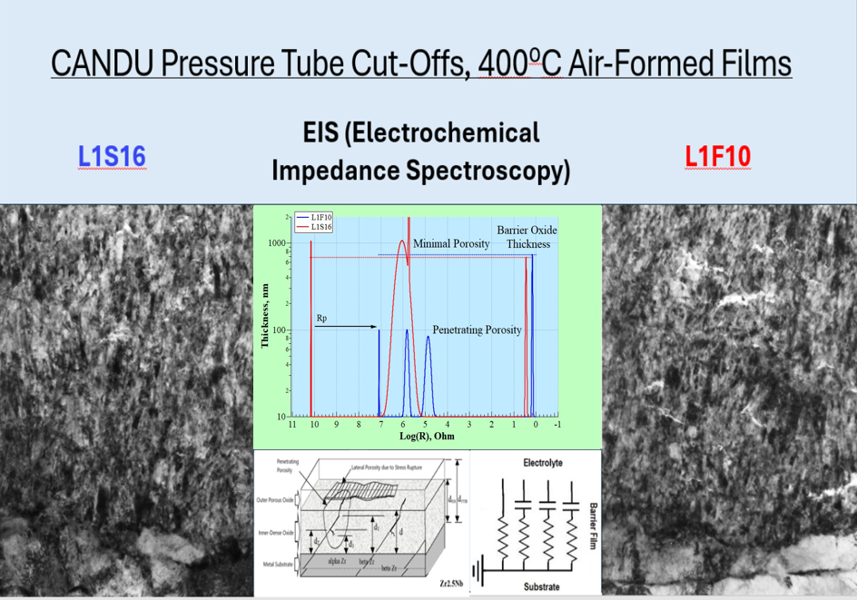
Figure 5: Composite Summary of EIS, TEM, schematic and circuit model.
Conclusion
Based on a 400C, 7-day air exposure on two PT offcuts, EIS can determine both barrier oxide thickness and internal oxide structure (penetrating porosity) that correlates to in-service behavior.
References
- Maguire, M. and B. Leger, “Oxide Film Thickness Measurements of Ten Specimens”, AECL Report RM-RMRB--00021, Aug 1996.
- McRae, G. A. and M. A. Maguire, "Electrochemical Impedance of Anodic Films on Zr-2.5Nb." Journal of The Electrochemical Society 149: B123-B129, 2002.
- McRae, G. A., M. A. Maguire, et al. "A Comparison of Fractal Dimensions Determined from Atomic Force Microscopy and Impedance Spectroscopy of Anodic Oxides on Zr-2.5Nb." Applied Surface Science 19: 94-105, 2002.
- M.W. Phaneuf, N. Rowlands, G.J.C. Carpenter and G. Sundaram, “Focussed Ion Beam Preparation of Non-Semiconductor Materials”, in Mat. Res. Soc. Symp. Proc., Materials Research Society, Vol. 480, pp. 39-48, 1997.
- O.T. Woo, “An Oxide Cross-Section Made By A Focussed Ion Beam System”, memorandum to V.F. Urbanic, FCCB-97-588, 1997 December 5.
- Maguire, M. A. and G. A. McRae, “Offcut Screening Test to Identify PT Susceptibility to D Ingress”, CANDU Owners Group, Inc. Report COG-03-1018, March 2004.
- Maguire, M. A. and G. A. McRae, “Offcut Screening to Identify PT Susceptibility to D-Ingress”, CANDU Owners Group, Inc. Report, COG-03-1080, December 2004.
- Ploc, R. A., H. M. Nordin, et al, “The Effect of Surface Finish on Corrosion and Deuterium Ingress of Zr-2.5Nb Presure Tube Material”, AECL Report FC-CSS-00022, Jan 2003.

