Electrical Impedance Spectroscopy of Coatings
ABSTRACT
Electrochemical Impedance Spectroscopy, EIS, is a powerful technique to both characterize and evaluate coatings and other barrier films. Traditionally this meant to collect spectra of the current response to an electrical stimulus as a function of frequency. The spectra would then be analyzed by choosing an electrical circuit containing elements (parameters) describing the system. The difficulty of this approach is the choice an appropriate circuit model and the fit optimization required to fit the data to the proposed model.
A different approach is suggested in this article; the model circuit is chosen based on how the instrument interprets the response to the stimulus. It is argued here that the instrument sees the response in terms of independent current pathways, dependent on the applied frequency. This reduces the choice of many models to one model: a parallel combination of active elements; each representing a characteristic feature. Each active element (pathway) contains a series faradic component, a resistor (R), and a reactive element, a Constant Phase Element (CPE). Thus, the model is based on Debye elements (series R-CPE), current paths and cut-off frequencies rather than a Randles elements (parallel R-CPE), relaxation responses and time constants.
The significant difference using the Debye approach is clarity, capability, and physical interpretation. Clarity because there is only one modeling circuit. Capability because the model both simplifies determination of initial values of parameters and simplifies the fit optimization process used to achieve fit convergence. Physical interpretation because only electrical parameters that can be supported by data are used calculate parameters of the proposed physical model. The Debye approach focuses on fitting the spectrum and then determining physical model parameters from the fit parameters. The Randles approach focuses on proposing a physical model before the fitting the data.
The usefulness of the Debye approach is demonstrated in this article.
INTRODUCTION
The traditional Randles approach is to choose a physical electrical Equivalent Circuit (EC) model that describes the coating based on an arrangement of series or cascading parallel R-CPE elements and the data is fit to the model. In contrast the proposed Debye approach describes each response as a series R-CPE element and then the number of elements (current paths) that can be supported by the data are included. Figure 1 shows a typical Randles circuit used for coatings. In contrast, Figure 2 shows the same circuit elements in arranged in Debye form. Both circuits fit the data and each set of parameters can be used to determine the other.
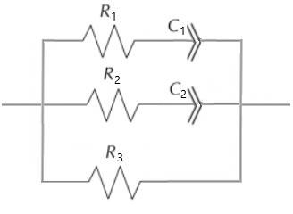
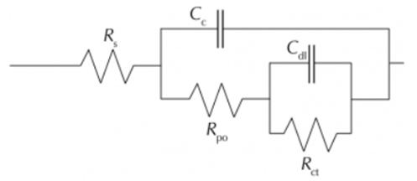
Figure 1: Randles Model for Coatings Figure 2: Debye Model for Coatings
Using the Debye model a Constant Phase Element, CPE, is used for the frequency dependent term. The generalized CPE can be used to describe most common physical characteristics of coatings. The impedance of the CPE is:
Z_{CPE} = (1/Cω^{n}) [1]
An intact high impedance coating requires one, near-ideal R-CPE response; four parameters. A compromised coating will require multiple CPE elements, each requiring three parameters. The final parallel resistance, R, describes the faradic resistance at low frequency. This simple change in perspective makes an incredible difference in the application of EIS.
DISCUSSION AND RESULTS
The focus of the Debye approach is on independent current paths. Thus, it is not a matter of relaxation responses and time constants, but a matter of current paths and cut-off frequencies (F_{c}). Each R-CPE path acts as a high-pass filter: at frequencies greater than F_{c} the current is limited by the series resistance and at frequencies less than F_{c} the CPE blocks the current. Thus, each observed response affects (dominates) the impedance response over a certain frequency range.
Using the Debye approach, only responses that dominate over a certain frequency range can be determined by the technique. It is not a matter of whether a response (i.e., a characteristic of the coating) is present, but whether it can be determined within the spectral range examined. For coatings, physical characteristics can be inferred from the electrical parameters. The R-term represents the faradic resistance leading to a Debye response, which is characteristic of the source of the response. An R-value close to the supporting electrolyte is the effective coating itself. An R-value greater than the electrolyte indicates a characteristic within the coating (i.e. internal porosity). The C-value is inversely proportional to the dielectric thickness, d = ee’A/C). The n-value is used to fit non-ideal behavior.
The physical meaning of the n-term is better understood by the fact that EIS is a macro-size technique sensitive to micro- of nano-size characteristics, numerous contributions to an overall characteristic. Thus, ω^{n} represents the population distribution of micro- or nano-size individual contributions to a macro-size physical characteristic. The Bode plot in Figure 3 demonstrates this principle. The parameters used to simulate the response are shown in the graph legend.
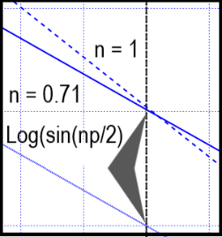
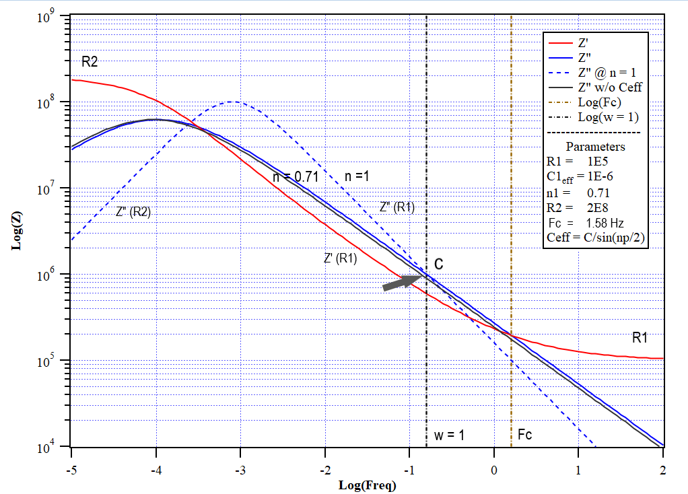
Figure 3: Bode Plot of a single response Debye Equivalent Circuit
The real component of the impedance, Z’ (in red), is:
Z’ (R1) Z’ = R1 < (1/Cω^{n} ) * cos(πp/2)) < R2 [1]
The high and low frequency limits are R1 and R2, respectively and the expression in-between describes the frequency dependence. The corresponding imaginary component of the impedance, Z” (in blue), is:
Z” (R1) Z” = (1/C ω^{n}) * sin(nπ/2) [2]
The vertical lines are Log(ω) = 1 and Log(Fc). The blue linear sloped lines on either side of the peak are described as:
Z”(R1), (high frequency side) Log(Z”) = (-n) * Log(ω) – Log(C) + Log(sin(πp/2)), and [3]
Z” (R2), (low frequency side) Log(Z”) = (n) * Log(ω) – Log(C) + Log(sin(πp/2)) + Log(R2/R1), [4]
where n is the slope on either side of the peak.
The Effective Capacitance, C_{eff,} is defined as the value of Log(Z”) at ω = 1, where equation [3] becomes:
Log(C_{eff}) = Log(Z”@ ω = 1) = Log(C/sin(nπ/2)) [5]
Equation [5] solves the problem of units of capacitance from Farads*s^{(n-1)} to Farads as shown using the inset graph in Figure 3. The value of n can range from ideal, n = 1, to random (disperse) n = 0.5. At n = 1, C_{eff} = C. At n = 0.71, C_{eff} = 0.9 * C. At n = 0.5, C_{eff} = 0.707 * C. The lower the value of n, the wider the Z” peak becomes; indicating a the wider distribution of the contributions to the overall characteristic response.
The Debye approach not only solves the dilemma of choosing an EC but also offers a concrete physical description of the coating. Each R-CPE parameter set contains information of the source and the type of the response (e.g. double layer, coating thickness, internal coating features, Warburg diffusion, charge transfer etc.). However, only the responses supported by the data are included in the EC. Furthermore, only responses that effect the spectrum can be determined. Thus, there may be characteristics in a proposed physical model that cannot be determined from the data.
Using the Debye approach:
- Individual responses can be added or subtracted during fit optimization.
- Each response (i.e. current path) behaves like a high-pass filter having a specific cut-off frequency, fc, and dominates the spectra over a certain frequency range
- Initial parameter values can be obtained from estimating the position of Fc; the R value from Z’, C value from Z”, and n by the slope of log Z” about Fc.
- Physical attributes R (pathway resistance), d (dielectric thickness), Fd (population distribution) can be directly determined from the circuit parameters R, C, and n.
- Fit convergence is achieved by user directed, auto/manual, hold/release fitting.
- Linearity, Causality, and Stability are inferred by the fit and fit residuals; KK transforms are not necessary.
- Error in parameters, experiment error, and influence of each response has can be determined during the fit.
EIS a robust, macro-size technique sensitive to micro/nano-size features, able to decern multiple features of the system. The Debye approach overcomes many of the difficulties concerning modelling, fitting, and reporting results. The following three examples of 1) a simulated coating failure, 2) anodic oxide film development, and 3) thermal oxide film degradation are presented below.

- Simulated coating failure - Table 1 shows circuit parameters (and Fc) used to simulate the data.
Table 1: Simulation Parameters

Figure 1 is the Bode Plot of the fit to the data. A gradual drop in impedance magnitude and phase angle is typical of coating failure.

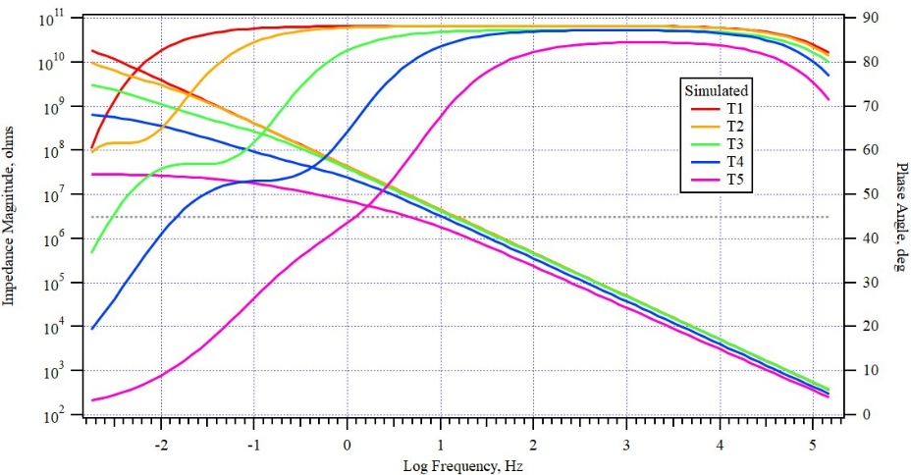
Figure 1: Bode Plot of Simulated Coating Failure
Figure 2 shows the Gaussian line presentation of the results; resistance the position, thickness the height, and width proportional to the population distribution. The inset graph is a magnified view of Response 1 showing the decrease in effect thickness (height) and widening population distribution (width). The peaks on the at the left are for the 2nd response and R3. For presentation purposes the height of R3 is arbitrary set to the height of the d2 parameter.
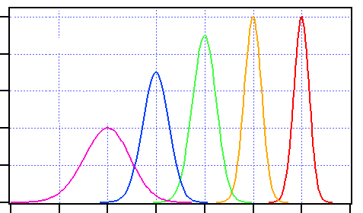
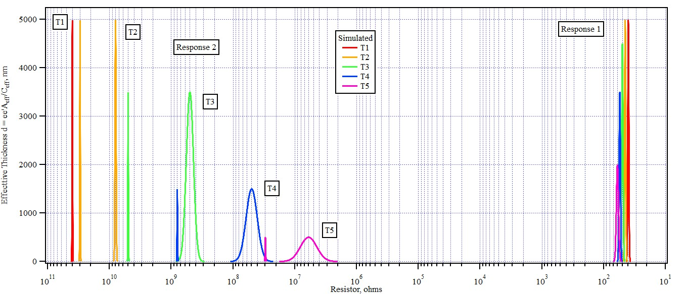
Figure 2: Calculated Gaussian Line Graph. Two response (left) and response 1 expanded (right).
The progression of coating failure can be appreciated using Figure 2. Data set T1 is the initial coating with only one response: solution resistance 40 ohms, thickness 5000 nm (5 μm), and n = 1. The other four simulate coating failure. For each succession, the effective coating thickness decreases (right expanded view). The 2nd response reveals the increasing in penetration of the electrolyte into the film (decreasing dielectric thickness) and an increasing population distribution (peak width). The low frequency resistance, R3 decreases as well. What the simulation does not show is the effect of surface area on the calculation of d2. In actual coatings, failure initially occurs only at a few small areas, which would cause d2 to be higher than expected (d = ee’A/C_{eff}). This anomaly is observed for changes in thermal oxide films during a 196-day exposure to 300C water.
- EIS of Anodized Films on Zr-2.5Nb
Anodization of the two phase Zr2.5Nb alloy results in a polycrystalline oxide film with high internal stress. When the stress exceeds a certain threshold a sudden cascading fracture event occurs. This cascade-rupture behavior mechanism is demonstrated using five anodized potentials of 20, 60, 100, 140 and 180 volts. Table 2 shows circuit calculated physical parameters and the corresponding F_{c} values. For the purpose here, data is fit to 3-responses. The experiment error (i.e. normalized sum of the residuals) is between 2.3% and 4.4%. Some parameters are correlated to one another, which results in two or more parameters having high error values. To overcome this situation, each parameter can held/release to obtain fit values. Once the values are determined, one of the parameters can is held during the final fit to observe the error in other parameters. The result of this situation is shown by a “H” value in the parameter error column (R3 @ 140V and n3 @ 60_2V). The log Fc (cut-off frequency) values are reported below the parameter values. Fc2 shows a decreasing trend with increasing anodization voltage, while for Fc3, there is a sudden change between 60 and 100 volts.
In addition to the 3-reponse fit, a 4-response fit can achieve, which reveals that the mid-frequency response can be resolved into two responses. There is a marked improvement in the experiment error, 1.2% for the 4-response, while still having acceptable parameter error. This is shown for the 60-volt data in Table 2.

Table 2: Anodized Zr2.5Nb. Sharp transition from 100 to 140 Volts in Fc1 and Fc2
Figure 3 shows the Bode plot for the 3 – Response fit. Although axis labels are not shown, the left axis in Log|Z| in ohms and the right axis is Phase Angle in degrees. There is a dotted horizontal line drawn at 45 degrees as an arbitrary reference point where Z’ = Z”. A sharp transition occurs within the barrier oxide between 60 and 100 Volts indicating a cascading fracture event. However, it is difficult to observe the interaction in the parameters that are responsible for this sudden behavior solely from the Bode plot.
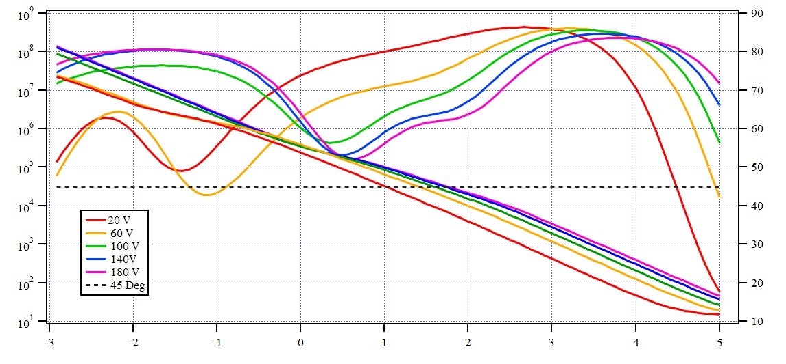
Figure 3: Bode Plot for Anodized Films
The Gaussian graphical presentation resolves this deficiency by showing all the parameters together in a stacked line graph, as shown in Figure 4. The inset window for the 1st response, shows oxide film growth as a function of anodization voltage; the film grows from about 50 nm at 28V to 400 nm at 180V.
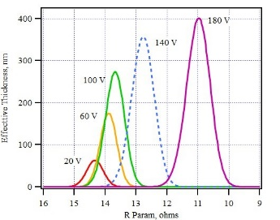
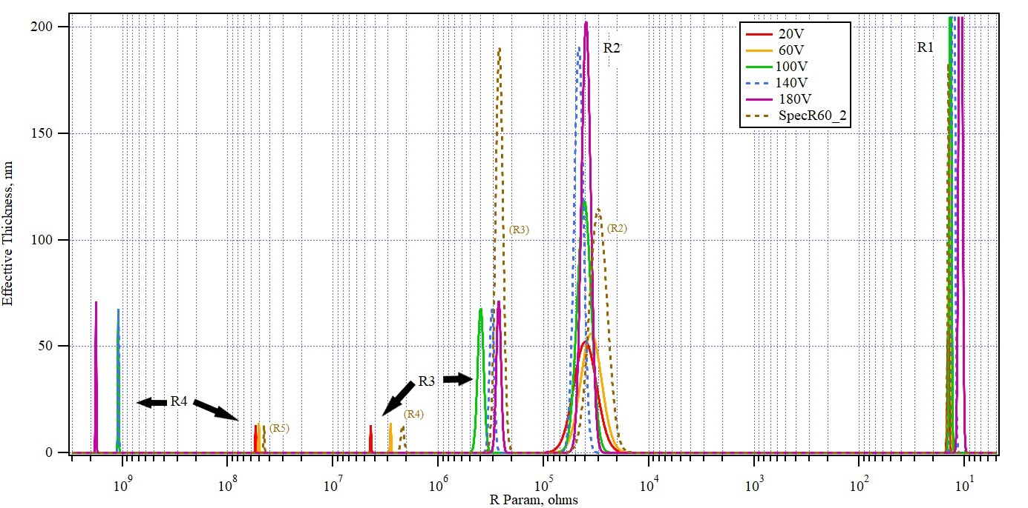
Figure 4: Gaussian Line Graph for Anodized Films
Despite the increased thickness of the barrier oxide, the internal porosity of the barrier oxide film, observed by the 2nd and 3rd responses, reveals more detail of what occurs with anodization voltage. The fact that multiple responses are supported indicates multiple independent pathways for the current. Like the simulated data, the oxide thickness of the 2nd and 3rd responses is lower than the oxide film itself. This implies that the features within the oxide film may have an effective area close to that of the ascribed surface area of the occluded cell. This is to be expected from the polycrystalline structure the oxide.
Figure 4 show that the cause of changes observed in the Bode plot, is a result of changes in the internal structure of the of the oxide with increasing anodization. For the 2nd response, R2 leading to the dielectric feature (CPE) remains constant, while the apparent thickness increases with increasing anodization. This implies a ‘healing’ effect of the internal porosity. The situation for the higher resistance 3rd response is different. There is a sharp increase in the R3 between 60 and 100 volts, while at the same time a sharp decrease in the d3. This would imply that the cascade rupture event allowed electrolyte closer access to the metal/oxide interface while at the same impedes current flow along the porosity. In addition to the increase in R3 there is also a dramatic increase in R4. An explanation for this is beyond the current scope, however the Debye approach, along with presenting results as a Gaussian line graph certainly reveals more details of the barrier oxide than were available merely from the Bode plot and much clearer picture than comparing individual parameter values reported in Table 2.
As mentioned above, the 2nd response can be resolved into two responses, as shown for the 60-volt data. Resolving the 2nd response reveals that one is similar to the parent 2nd response and the other similar to the 3rd response. This reveals that even before the sudden rupture event there are subtle changes that occur within the barrier oxide.
- EIS of Thermal Films on Zr-2.5Nb in 360C water

The last example is of the Zr2.5Nb alloy subjected to 360C high temperature water, simulating in-service behavior in a nuclear power reactor. The EIS measurements were performed at 28-day intervals for the 196-day test. Table 3 show results after the 28-, 84-, 112-, 140-, 168- and 196-day exposures. Table 3 contains, the circuit and physical parameters, their parameter error, experiment error and Fc. Like anodization, thermal oxidation follows a growth/rupture mechanism. This is most significant between 140- and 168-day interval as revealed by sudden shift in the Fc values. However, unlike the anodized film, the changes under thermal conditions (360 C water) are more subtle, with a larger population distribution, i.e. lower n values and wider Gaussian peaks.
Table 3: Zr2.5Nb 28-day exposures to 360C water.
For brevity, the Bode plot is not shown. Figure 5 is the Gaussian line-graph presentation. The 1st response (R1) indicates the thickness of the inner dense-oxide layer only. Any porous outer oxide layer, being saturated by the electrolyte, is indistinguishable from the electrolyte itself, thus invisible to the EIS technique. Total oxide formed is obtained by weight gain measurements not included here. The grow-rupture of the oxide occurs several times during the 196 day-exposure, resulting in a decrease of barrier oxide thickness and changes in internal porosity.
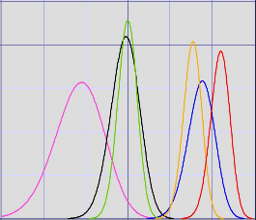
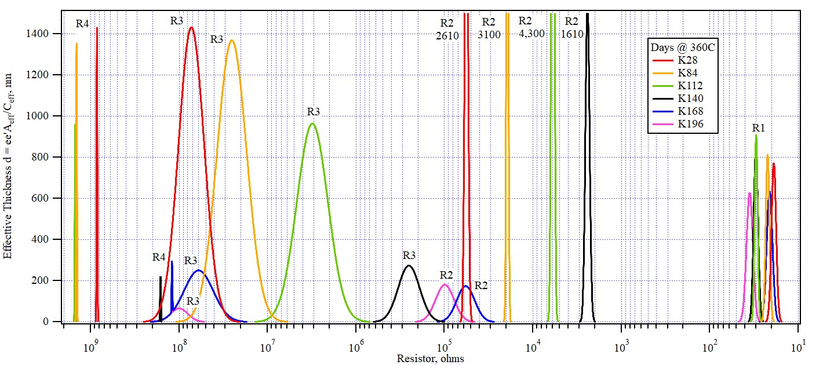
Figure 5: Gaussian Line Graph for 360C Thermal Films
This decreasing oxide trend is shown in the inset graphic at low resistance. After 28 days the barrier oxide thickness limit is about 800 nm. This increases to about 900 nm after 140 days and then sharply decreases to a limiting thickness of 600 nm after 196 days: an indication of decline of the protective barrier film.
Changes within the barrier oxide are much more dramatic. The 2nd response feature, after the 140-day has an apparent oxide thickness greater than the barrier layer. This is because the effective area of the response is less than the occluded specimen area (i.e. d = ee’A/C). This trend changes abruptly after 140-days, when the thickness, d2, drops suddenly below 200 nm, while the R2 increases back to the original value observed at 28-days. The 3rd response features (indicated as R3) also has an effective area less than the occluded area, however it has a much wider population distribution. The changes in R3 preclude the changes observed in the R2 response (Also observed for anodic films). Between 112 day and 140 day there is a sudden change decrease in R3, associated with a decrease in d3 to about 280 nm: much below the barrier layer thickness of 600 nm. Following the rupture event, R3 never recovers but instead the value of R3 and the dielectric thickness continue to decline. From the corresponding weight gain data (not included) this rupture, and decline occurs where the oxidation rate changes for parabolic to linear (i.e. ‘breakaway oxidation).
CONCLUSIONS
These examples demonstrate the usefulness of the EIS technique in studying barrier coatings. The Debye approach of using a parallel (independent) combination of R-CPE paths is both capable in fitting barrier coatings, as well as offering a physical interpretation of the barrier coating. Using the Debye approach, the number of responses in the EC are those that the data can support. The Debye approach solves the choice of EC model, allows determination of initial values from the Bode plot, simplifies fit optimization, and improves both the physical interpretation and presentation of results. Finally, recognizing models based on Debye and Randles approaches are equivalent circuits, Randles parameters can be calculated from Debye parameters. The Debye approach has advantages of fitting data, while physical attributes can be calculated from the fit parameters. This break from the traditional approach to a parallel Debye model will unify interpretation of results and encourage wider use of the EIS technique.

