PEDRA 9.0 Fitting EIS Data - Re-Thinking the Traditional licence
In 2006 PEDRA 6.0, Parallel Electrical Dielectric Response Analysis, introduced as a new way of interpreting impedance spectra. Now, in November 2025 a completely revised, PEDRA 9.0, is here.
The PEDRA method utilises an Expandable Equivalent Circuit Model (EECM) to establish the appropriate number of parameters that best fit the data accurately. In contrast, the traditional approach uses a perceived Equivalent Circuit Model, ECM, to fit the data. The traditional approach often leads to either too many parameters with high parameter error (uncertainty), or too few parameters insufficient to fit the data.
PEDRA 9.0 supports two EECMs, a Randles cascading resistance - dependent response model, and a Debye parallel resistance - independent response model. Figure 1 compares the two models; the grey area is the EECM. The three surrounding elements of the model describe limiting conditions outside the EECM: parallel phantom capacitance in high impedance/low current applications, series inductance in high current applications and parallel low frequency inductance in active corrosion applications. The discussion of these surrounding elements falls outside the scope of this article. Here the focus is the EECM and demonstrating features of PEDRA 9.0.
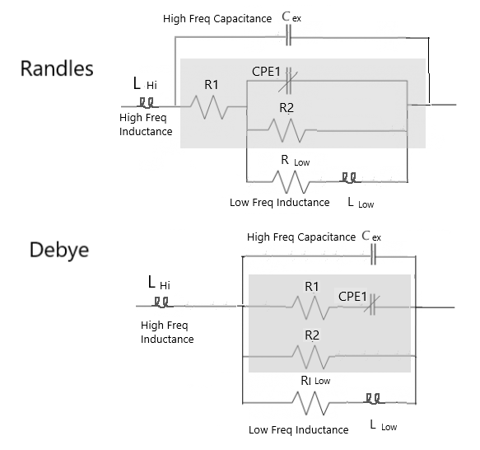
Figure 1: Randles and Debye EECM with Surrounding Elements
The PEDRA approach emphasises 'current path' and 'response dominance' as functions of frequency, rather than fitting this data to a presumed ECM. Appreciating that all current paths are comprised frequency independent term (resistance) and a frequency dependent term (capacitive or inductive), each current path is interpreted as an electrical by-pass filter, rather than a relaxation response described by its time constant. Figure 2 shows the difference between a series R1-CPE1 Cut-Off frequency (Fc) and a parallel R2||CPE1 time constant (Ftc).
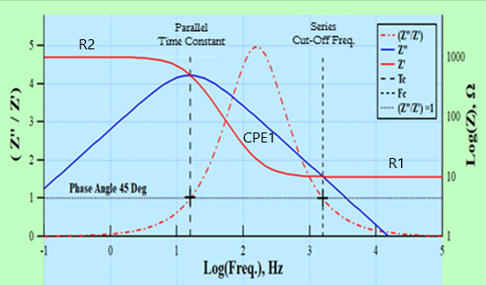
Figure 2: Parallel Time Constant 1/R2*CPE1 and Series Cut-off Frequency 1/R1*CPE1
In this example, Fc is the frequency below which the capacitance starts to limit current through one path to encourage current toward a lower impedance path. In this way, capacitive current paths act as high-pass filters and Inductive current paths act as low-pass filters. In contrast, Ftc, represents a relaxation response where the imaginary component of the impedance response reaches a peak.
This article demonstrates the fundamentals of PEDRA using successive scans of a high residual stress oxide film on Zr2.5Nb anodized to 100V under ambient condition. The Zr2.5Nb disc sample was in a held in a TFE flat specimen holder and positioned inside a three-electrode glass cell filled with 0.1 molar K2SO4 electrolyte at ambient room temperature. The setup included a Zr2.5Nb working electrode, a platinum counter electrode, and a Calomel reference electrode. After anodization the specimen, once a steady state open circuit potential was achieved, a 10 mV AC signal was applied, and the frequency scanned over the range of 1 mHz to 10^5 Hz at 12 points per decade (i.e. total of 120 points over 10 orders of magnitude). Eight consecutive scans were performed, each approximately 95 minutes long, making the total experiment duration 13 hours.
Figure 3 shows a 3-response fit to the data after the initial scan. The PEDRA screen consists of three user panels: Main Graph, Information Panel and File Control. In addition, because PEDRA runs under IGOR PRO, all the functionality of IGOR PRO is available via the top grey header.
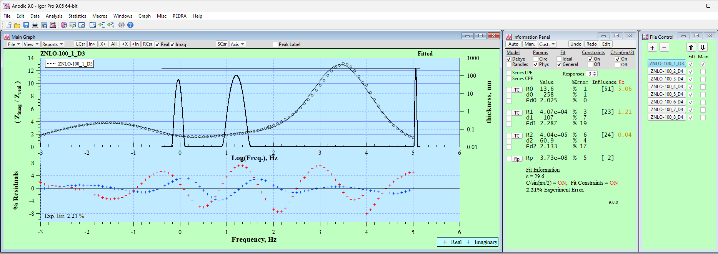
Figure 3: Three-response fit to 100V Anodized Film on Zr2.5Nb.
Fit to data on Zimag/Zreal (left axis) and SpecView, oxide thickness (right axis).

The Main Graph reveals two unique features of the PEDRA approach. To begin with, the fit to the data is displayed using a simple ratio of (Zimag/Zreal) rather than phase angle, ArcTan(Zimag/Zreal). This display emphasizes the current path-dominance (as a function of frequency) interpretation. Secondly, a “SpecView” representation derived using a Gaussian equation is used to construct a line graph of the EECM parameters as function of Log frequency: Fc as peak position, thickness (derived from the capacitance) as peak height, and power law term as peak width. The ladder power law term describes the distribution of micro- and nanoscopic elements that contribute to a larger characteristic response, which is the direct result of EIS being a macroscopic technique that is responsive to the structural details at both micro and nano scales. The fit residuals below the display help spot outliers and check for nonlinearity or stability concerns.
The fit axis can be changed to either Log|Z| and Phase Angle (Figure 4), or Log(real) and Log(imag) (Figure 5), using the Axis drop-down menu on the control bar. Additionally, you can use options in the control bar menu to add or remove outlier data points.
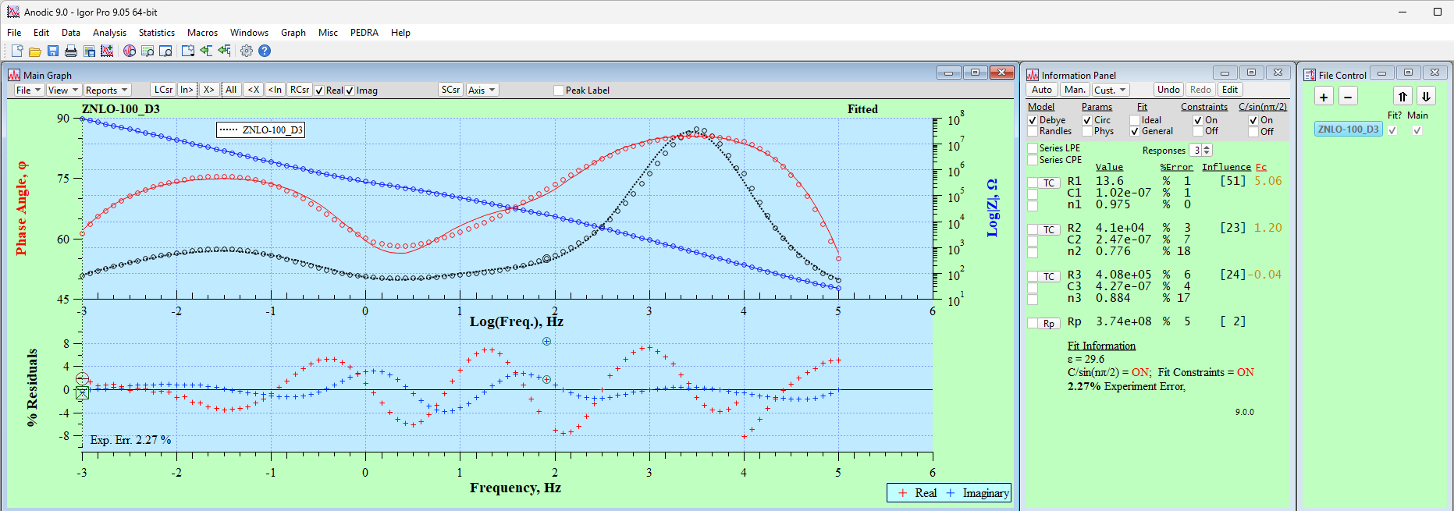
Figure 4: Three-response fit to 100V Anodized Film on Zr2.5Nb.
Fit to data on Phase Angle (left axis) and Log|Z| (right axis).

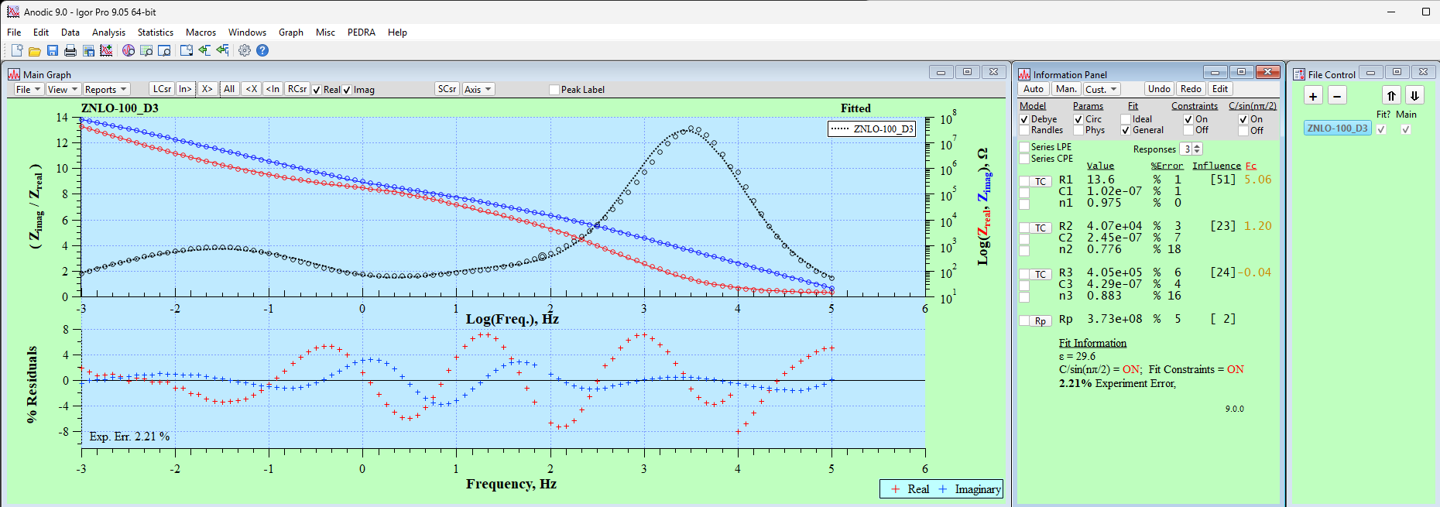
Figure 5: Three-response fit to 100V Anodized Film on Zr2.5Nb.
Fit to data on Zimag/Zreal (left axis) and Log(Zimag), Log(Zreal) (right axis).

The Information Panel (center) is used to set the fit conditions, estimate parameters using the TC button, hold/release parameters (check boxes) and display results. Fit condition choices (grey area) are:
- Debye or Randles EECM
- Physical (see Figure 3) or Circuit (see Figure 4) Parameters
- Ideal 2-parameter (n = 1), or General, 3-parameter response fit.
- Fit Constraints ‘On’ restricts parameter range to values set in Preferences.
- Frequency correction, C (effective) = C (fit) / sin(pi/2*freq), Farads, On or Off.
The File Control Panel on the right allows you to manage several data sets at once. Imported data files can be added with (+), remove with (-), and re-ordered by moving the highlighted file up or down. The left check box indicates whether the data has been fit, and the right check box allows the user to overlay the results of one file on another: either on the main graph or on the available graphical reports via the ‘Report’ pulldown menu in the Main Graph panel.
Although it is less significant, the data fit can also be assessed with the Nyquist presentation, as shown in Figure 6. Because of the large dynamic range of impedance, Log axis is required to view the fit to the data.
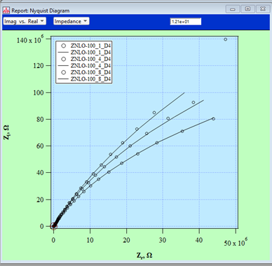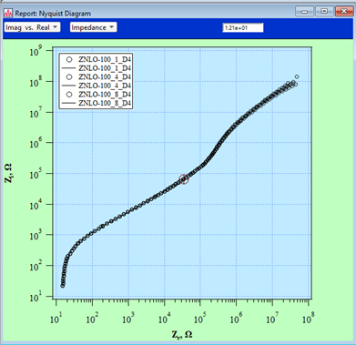
Figure 6: Nyquist Presentation, linear (left) and Logarithmic (right)
Close examination of the 3-response Bode plots in Figures 3 – 5 reveals that the fit at mid-frequency may not be optimum. An evaluation using 4-response fit begins by choosing "4" on the Responses toggle, estimating the response positions (Fc) to obtain starting values, and then fitting the data accordingly. The results indicate that the central response can be divided into two separate, yet similar, responses. Figures 7 and 8 show results for the Debye and Randles EECM, respectively. A check mark next to the Fd2 parameter in the Information Panel indicates that the parameter is held before the final fit. This necessary due the high correlation (proximity) between the two mid-frequency responses. Splitting the mid-frequency response, into two responses, is justified because it improves the fit, lowers both the Experimental Error (i.e. the reduced chi-square statistic) from 2.2% to 0.8% and errors in individual parameters.
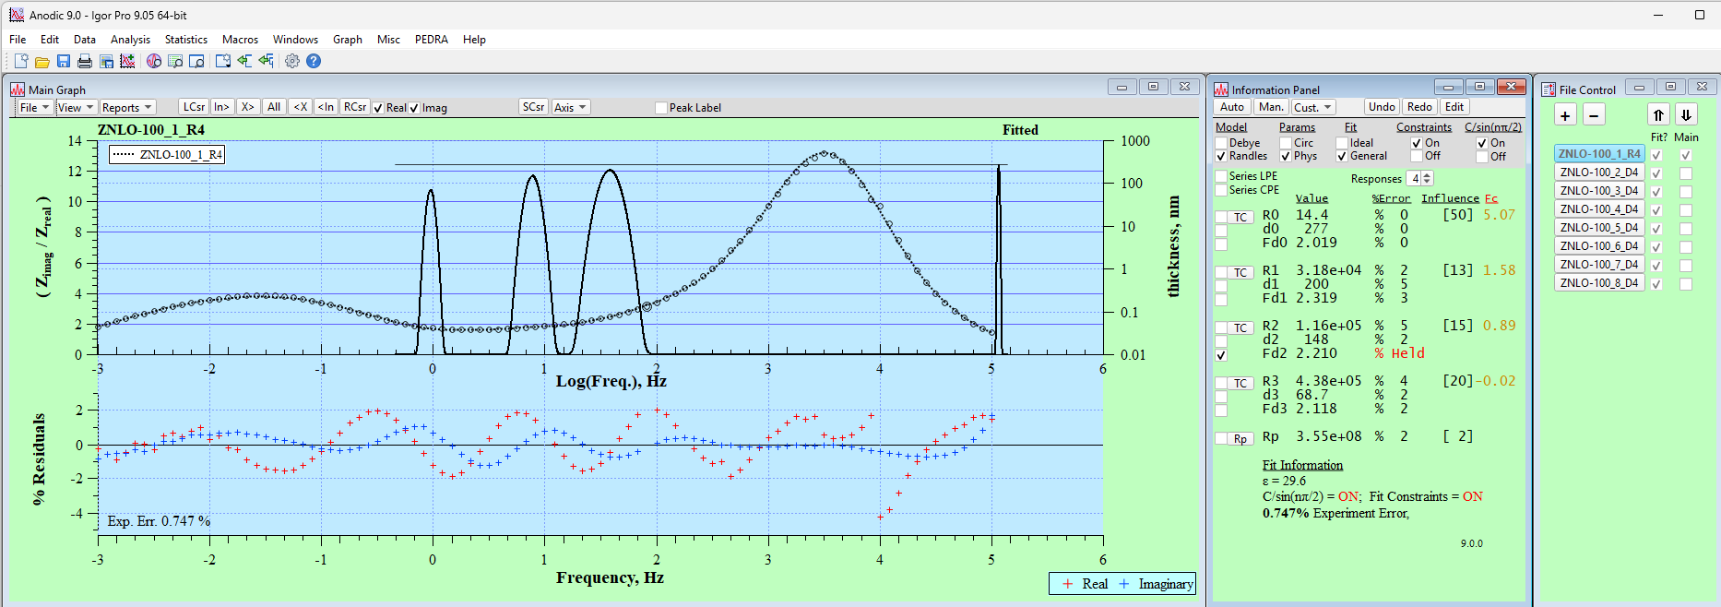
Figure 7: Randles EECM four-response fit to 100V Anodized Film on Zr2.5Nb; Fd2 Held.
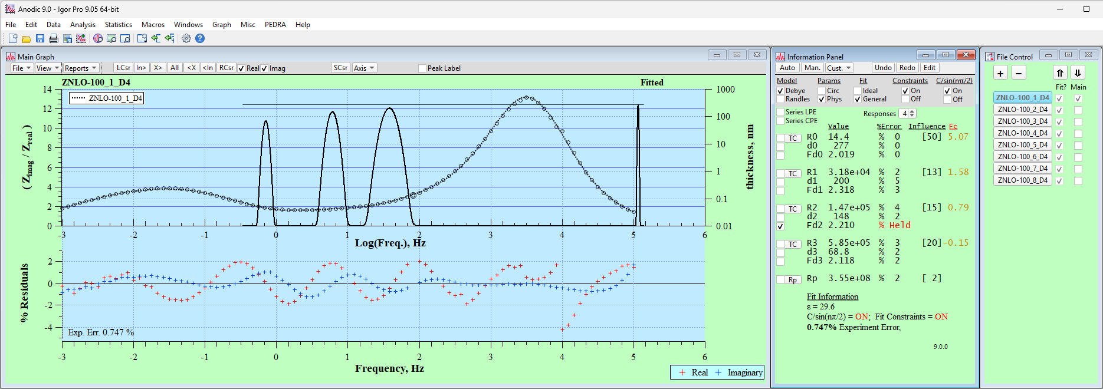
Figure 8: Debye EECM four-response fit to 100V Anodized Film on Zr2.5Nb; Fd2 Held.

Figure 9 shows the phase angle presentation and the result of if releasing Fd2 on parameter error.
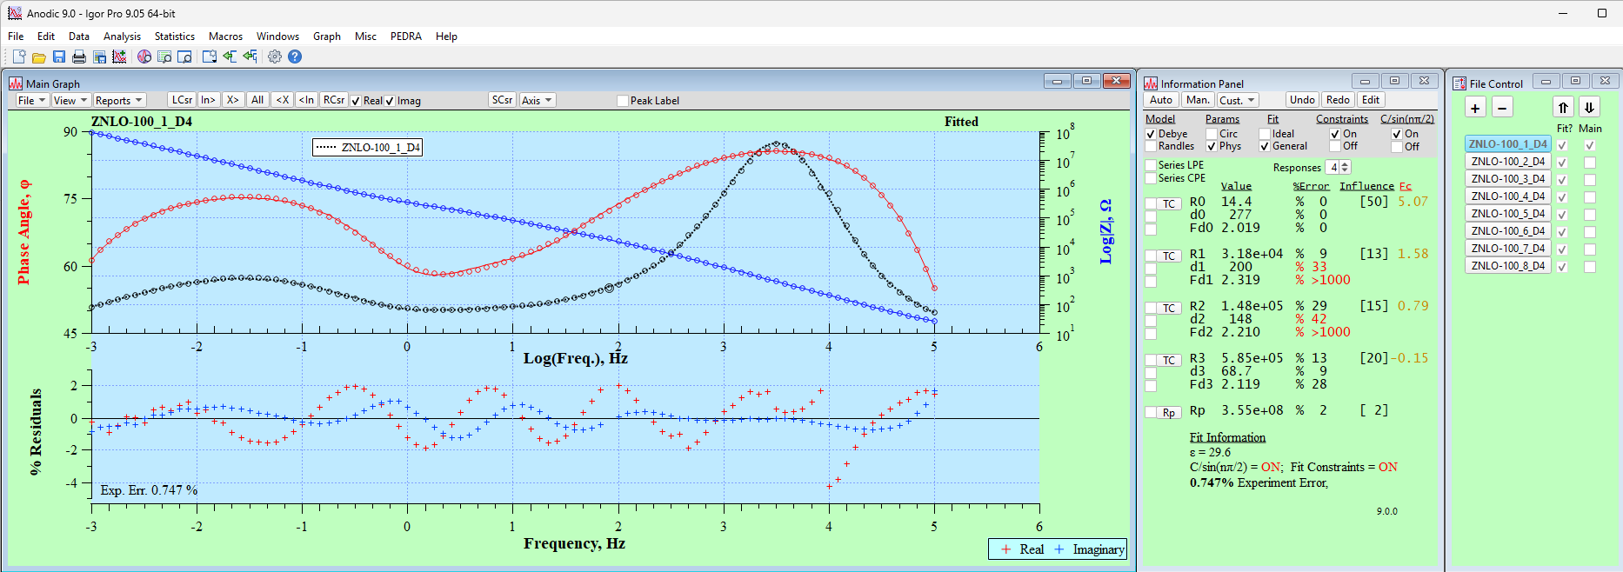
Figure 9: Debye EECM four-response fit to 100V Anodized Film on Zr2.5Nb; Phase Angle/Log|Z| Plot; Fd2 Released.
Table 1 compares 4-response fit for the Randles (left) and Debye (right) ECCM for the first scan results. As maybe expected for a high impedance (> 7 orders of magnitude) oxide film, the primary difference is in the R values. Both the fitted C and n (or d and df) values and ‘Data’ vs ‘Fit’ values remain very similar.
Table 1: Spreadsheet Fit Results; Randles (left) and Debye (right)
Table 2 compares the Physical parameters and their error of all eight scans for the Randles EECM (upper) and Debye EECM (lower). There are differences between using the EECMs, however they are difficult to appreciate from the table alone. Using a Gaussian line graph, SpecView presentation, can reveal the subtle differences.
The SpecView presentation of the Main Graph uses Log(Fc) to indicate its position on the Main Graph, which is consistent with the invariant Log(freq) x-axis. However, using Log(R) instead of Log(Fc) for the x-axis better shows how path resistance (inverse ionic conductivity) relates to its associated CPE dielectric response term. The remainder of this article will discuss reporting results using overlay SpecView plots with the Log(R) x-axis.
Figure 10 is the overlay graph of results of eight consecutive scans using the Randle EECM. Because a Log(R) x-axis is used, Rp values are included as distinct peaks using an arbitrary height of final response peak. Therefore, it is possible to observe all the dielectric responses and the low-frequency limit of R on a single line graph.
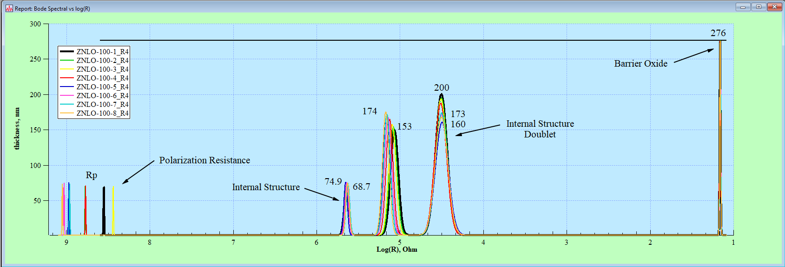
IGOR PRO's graphics features are next used to conveniently adjust the x-axis range to view details of individual responses. Figure 11 of the low impedance peak reveals no variation in the overall barrier oxide thickness over the period of the experiment. The barrier oxide thickness remains at 276 nm and the electrolyte resistance of 14 ohms.
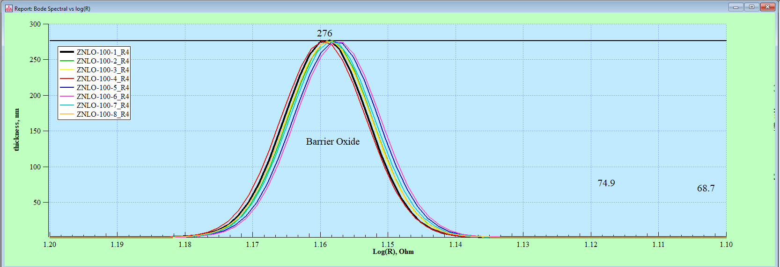
Figure 12 shows the mid-frequency (mid-impedance path) internal oxide characteristic doublet and the low frequency (higher-resistance path) internal oxide characteristic. The upper graph is using the Randles EECM and the lower graph the Debye EECM. For comparison, the range of the x-axis is the same for each EECM. As expected, R values for responses 3 and 4 are lower for the Randles model due to dependent, cascading arrangement of R. However, the thickness and population distribution (power law) for the two EECMs are similar.
For the mid-frequency doublet, both models reveal a gradual progression, a step-change, followed by a ‘settling’ behavior. The gradual and subsequent step change suggest a stress-rupture event. The abrupt change is slightly different for each mid-frequency doublet peak. It occurs first between the 3rd and 4th scan for the higher resistance peak and then between the 4th and 5th scan for the higher resistance peak. This suggests that the changes in the features depend on one another favoring a Randles EECM. In contrast to the mid-frequency doublet, the low-frequency characteristic remains essentially constant throughout the experiment.
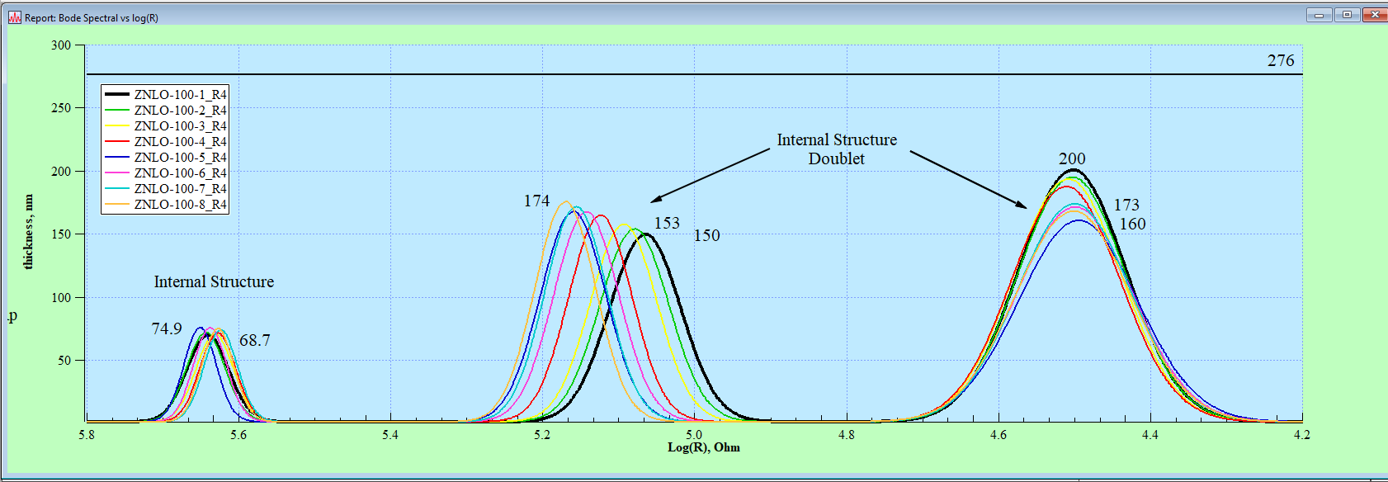
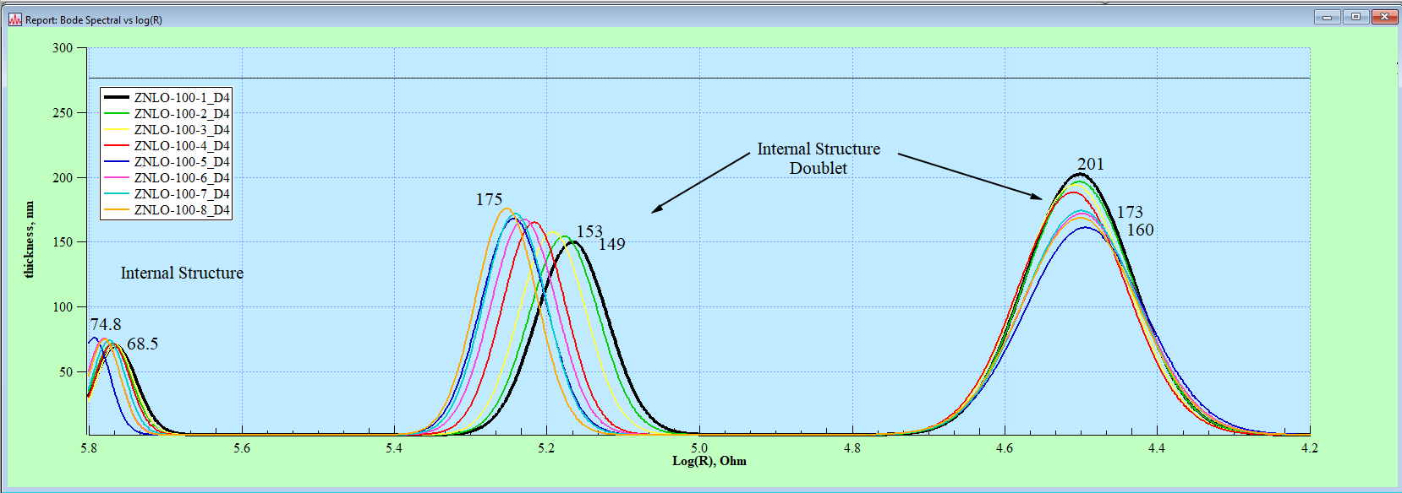
Finally, Figure 13 shows the associated changes in Rp. Before the step-change Rp varies between Log 8.4 and 8.8 (3 – 6 E8 ohms) while after the step-change Rp shifts to a narrower, higher range of 8.9 and 9.1(9 E8 to 1.1 E9 ohms). The effect of the step-change results in a higher impedance film.
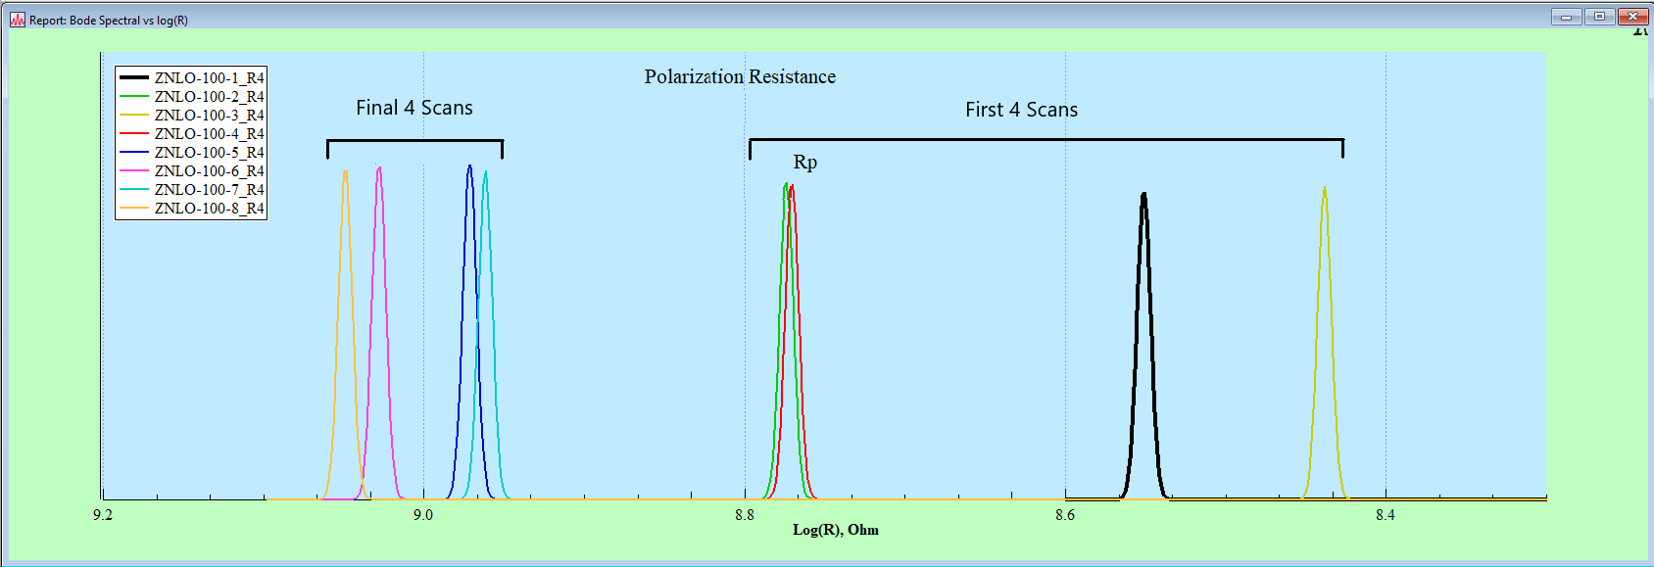
Conclusions
The PEDRA approach emphasises 'current path' and 'response dominance' as functions of frequency, rather than relaxation responses defined by time constants. The Expandable model, EECM, identifies responses backed by data instead of selecting an ECM based on intuition.
This approach has been demonstrated for an 100V anodic oxide on Zr2.5Nb, using PEDRA revision 9.0, capable of handling multiple data sets, two types of EECMs (Randles and Debye structure), user interactive iterative fit technique, and a unique SpecView line graph presentation; all wrapped in an open-source application running under IGOR PRO by Wave Metrics. PEDRA 9.0, having a MIT license, is available upon request.

